NHS RGBSpecialist help for Fibromyalgia. Page 1

**Patient Information Leaflet: PACING**

Pacing is the way all of us should balance our daily activity. It is especially useful if you have fibromyalgia as your energy stores are much lower and therefore balance becomes even more important.

Most people tend to do a lot when they feel good and not very much when they feel unwell. This can lead to big swings in activity and if you have fibromyalgia you may find that you over do it one day and then have several days recovering. The idea of pacing is to stop this swinging from one extreme to another so that you can start the process towards recovery.

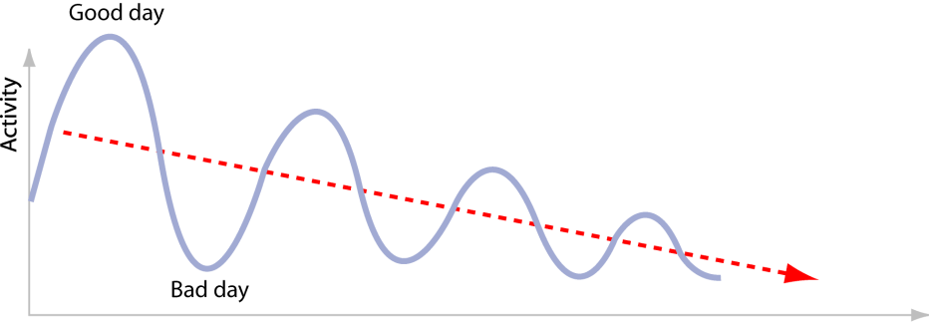

Before you start pacing you it is ideal to keep a record of your activity levels. You then need to decide rough maximum and minimum levels of activity which you will be able to do on good days and bad days. For example this might be 3 hours of activity on a good day (and this would probably feel too easy but you would keep your reserves up) and one hour of activity on a bad day (would feel tough but would be possible). You would then try and keep your activity between these limits on good days and bad days.

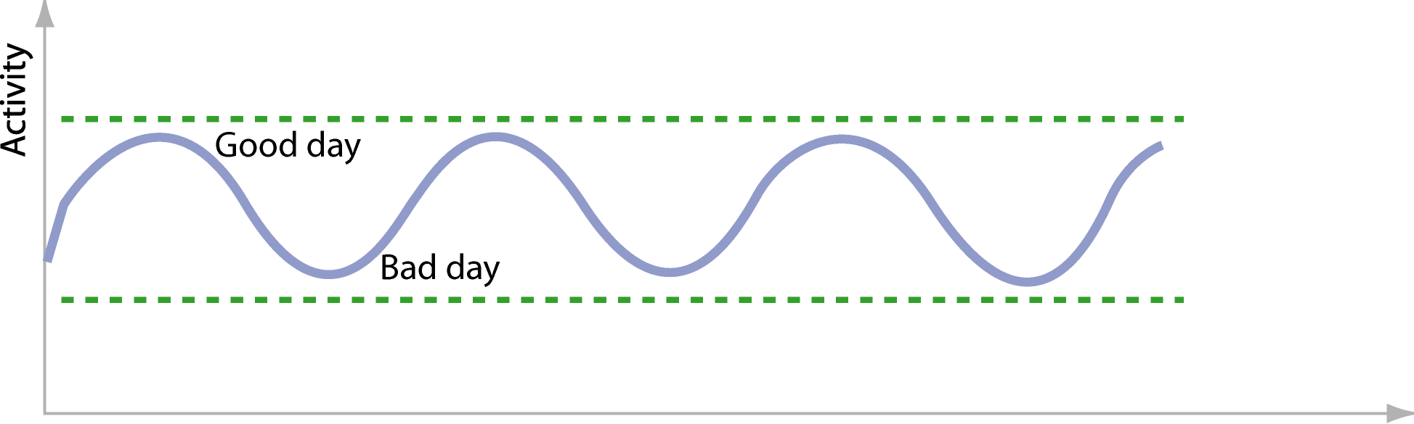

Over a period of time you will find that you can gradually increase these levels on both good days and bad days as you are storing up energy. Some people call this increase in activity graded activity but for many people this will happen naturally as you get better.

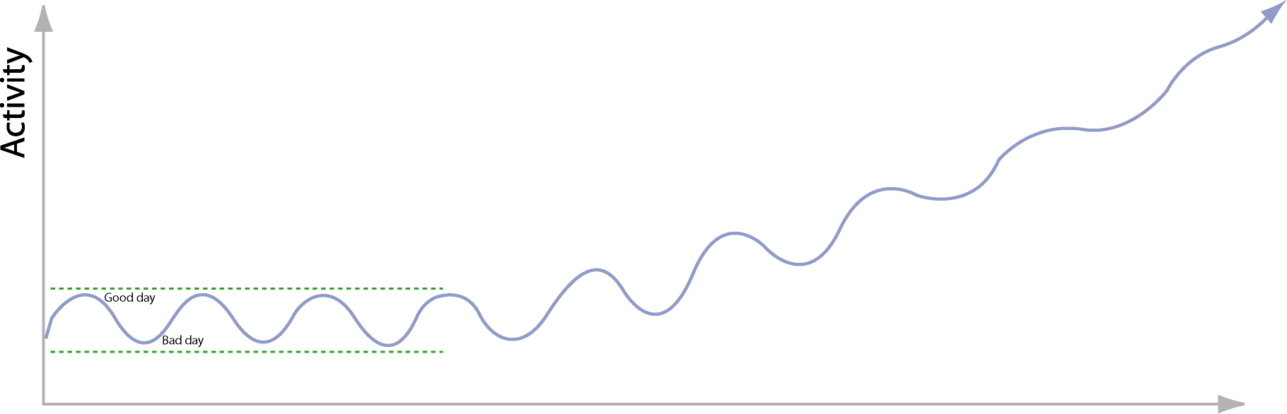

NHS RGBSpecialist help for Fibromyalgia Page 2

**Patient Information Leaflet: TAI CHI and GRADED ACTIVITY**

Once you have got used to pacing you are likely to naturally increase the amount you do as you have more energy. Some people find it helpful to formalise this into a graded activity program where you record what you do each week and try and increase it very carefully.

The two most important things to remember are:

* Ideally you must be successful at one level of activity almost all of the time before you increase it.
* You need to make small increases (typically no more than 15%) each time. This avoids the swings of over exertion and illness that can happen if you are not careful.
* The most beneficial exercise to increase in fibromyalgia is Tai Chi. To start with try 5 mins
* Here is a good starting video to learn some of the simple movements in Tai Chi
* Here is a good starting video to learn some of the simple movements in Tai Chi

<https://www.youtube.com/watch?v=vHBR5MZmEsY>

then a good NHS website is

<https://www.torbayandsouthdevon.nhs.uk/services/pain-service/reconnect2life/improving-health-and-fitness/tai-chi/>

and

[https://www.torbayandsouthdevon.nhs.uk/services/pain-service/reconnect2life/improving-health-and-fitness/tai-chi/tai-chi-shibashi-qig](https://www.torbayandsouthdevon.nhs.uk/services/pain-service/reconnect2life/improving-health-and-fitness/tai-chi/tai-chi-shibashi-qigong/)

when that is all manageable

* To progress initially at home  using other Youtube videos eg the Taiflow channel has several 5minute videos. See this link if you cant find it them
* <https://www.youtube.com/channel/UCxkLLizyaKhpeeZjK27Leqw/videos?view=0&sort=p&flow=grid>

The benefit of Tai Chi increases the more you build it up with the aim over 6 months  to be doing 2 times 40-60 minute classes a week or similar by then with some daily practice .

* There are many other good YouTube channels with lots of video to follow here is another one by the instructor Peter Chen
* <https://www.youtube.com/channel/UCYrf_ajxX_Ze1yuFyv7J1BQ/videos?view=0&sort=p&flow=grid>
* [Tai Chi: Beginner (youtube.com)](https://www.youtube.com/watch?v=aUs4NK2s170)

Other approaches to Graded Exercise for example:

* If you are able to read for 30 minutes in a day then you could increase this to 34 minutes each day. After a while, if this was successful, you could increase it to 39 minutes a day.
* If you are achieving three hours of activity successfully 5 days a week with just the occasional day off, you could then increase this to three hours and 20 minutes a day. If this was successful for a few weeks you could increase this to 3 hours and 50 minutes a day. This is a better approach than increasing straight to full days that often means that people manage on some days and have to rest on other days to recover.

The reason we call this graded activity is that you can use this approach to all activities in your life and it can be used for anyone no matter how severe their illness is. We think of activity as anything that stimulates the brain and includes watching television and talking on the phone as well as more obvious physical activity.

As a part of graded activity some people like to use graded exercise as a way of increasing their fitness.

**Graded Exercise**

Some people find this a useful approach either if they have a particular aim (such as walking children to school, going to the shops or managing steps) or if they are managing full time work or study and want to improve their fitness for sports. It is only a part of graded activity. There is some evidence from medical research that it can help people get better faster.

The most important things to remember are:

* You must have a baseline that is easily achievable. This is normally half the activity that you could achieve on a good day.
* You must increase the activity very slowly and be able to achieve each step before you increase another one.
* It is important to continue to use a diary so that you can document the progress that you make.

If you want to use graded exercise as part of your graded activity it tends to be a good idea to have some help with this. This could either be a therapist (physiotherapist or occupational therapist) or could be somebody experienced in a local gym. All sorts of exercise have been shown to benefit fibromyalgia including water based exercise, Tai Chi, aerobic and strengthening exercises.

NHS RGBSpecialist help for Fibromyalgia Page 3

**Patient Information Leaflet: SLEEP**

## What are good sleep habits?

Good sleep habits are often referred to as good sleep hygiene. There are many things that can be done to improve sleep. While most of these are common sense, life is very busy and we often don’t think about them. Here, we will give you some guidelines for what you should and should not do for a good night’s sleep. Many people have trouble with their sleep. If you are one of them, some of these simple things may help.

## What should I do in the evening?

Try to go to bed at the same time each night. The body has an internal clock and hormones that control sleepiness and wakefulness. This clock works best if there is a regular sleep routine. When working well, you will feel sleepy at bed time. Try not to ignore this by staying up, as this is a window of opportunity for sleep. Going to bed too early can also disturb your sleep. In the hour before going to bed, it is important to have a relaxing sleep routine. This may include a warm bath, reading quietly or a warm milk drink. Going to the toilet is important to avoid having to get up in the night.

## Are there things that I should not do in the evening?

Caffeine should be avoided for at least 4 hours before going to bed. This isn’t just coffee and tea. It is also found in colas and soft drinks. Smoking also makes it difficult to go to sleep, so there should be no cigarettes before going to bed or during the night. Alcohol might help you get to sleep, but it will make it harder to stay asleep. It makes sleep problems like snoring and sleep apnoea worse as well. Activities that are stimulating should be avoided in the hour before bed. This includes moderate exercise, computer games, television, movies and important discussions. Being in a brightly lit environment or the blue light of the computer can reduce evening levels of the a sleep-promoting hormone, melatonin. Don’t fall asleep on the sofa during the evening as it reduces your sleep pressure

and makes it harder to fall asleep when you go to bed.

## What about meals and sleep?

It is important to not be hungry at bedtime. But having a full stomach makes it difficult to sleep. The evening meal should be at least 2 hours before bedtime. Some people find that having a small snack at bedtime helps them to sleep better.

## What should I do when I’m in bed?

The bed must be comfortable. Warmth is important, both the temperature of the room and having enough blankets. Having warm hands and feet is essential. The mattress, pillow and blankets should be comfortable and restful. There should be no distractions in the bedroom. This may mean removing the television, computer, radio and telephone. If there is a clock in the bedroom, it should be covered to avoid watching clockwatching. If possible, don’t allow children and pets to be a disturbance.

## What should I do during the day?

One very important thing is to stay out of bed. Some people use the bedroom as a living room, where they study, watch television, make phone calls and read books. This will make it harder to sleep. The brain will no longer link the bed with sleep. The bedroom should be used for sleeping and intimacy only. As a rule, exercise is good for sleep, but not just before going to bed. The best times are in the morning and before the evening meal. Being out in the sun during the day will improve sleep at night. This will help with your body clock and the melatonin levels in the body. It is best to be outside in the early part of the day.

## What should I do if I can’t get to sleep?

Sleep is not something that you can force to happen. If you are not asleep within 20 to 30 minutes of going to bed you should get up. Go to another darkened room and sit quietly. Do not watch television, use a computer, eat, drink or do household chores. When you feel tired

again go back to bed. This helps your mind link bed with sleep – not with being unhappy and not sleeping. Do not look at the clock because no matter what time it is you will have an emotional reaction. Rest is good – it does not have to be sleep. Don’t label yourself as an insomniac

What if you can’t shut off your mind?

Some people lie awake in bed at night and cannot switch of their thoughts. If this is a problem, set aside a ‘worry time’ during the evening. Use this time to think about what has been happening during the day, make plans and possible solutions. Then don’t think about these things until the next day. Keep the hour before bed as your wind down time – develop a routine that prepares your body and mind for sleep. Listen to quiet music or do relaxation. Remember that we can never shut off our mind. Our thoughts continue all the time, so try to make them calmer thoughts. Create a favourite fantasy place. Or daydream of your favourite holiday spot. If other thoughts come in, consider them for a moment and then try to gently replace them with calm thoughts.

Are naps good or bad?

It depends. Remember that the average adult sleeps for between seven and nine hours a day. Naps will take up some of this time. But if you are taking short afternoon naps without any problems, then you might want to keep doing this. On the other hand, naps in the evening, or dozing in front of the TV, can make it harder to get to sleep at night.

What about prescription medicines and

sleep?

Some of these will make it easier to get to sleep. But others will keep you awake. It is best to take them only when your doctor or pharmacist says so. Sleeping pills can be good when a specific event in your life is making it hard to sleep. But they are only a short term fix. If you take regular doses, they will stop working. Once you stop them, you might find it harder to get to sleep. Also they can make you sleepy during the day.

How much sleep do I need?

Most adults need between seven and nine hours sleep each day. But this may include naps and time spent dozing in front of the TV. Be realistic about your needs. Younger people have different sleep needs. If you are a poor sleeper it is very important you do not spend too long in bed. Spend no more than 8 or so hours in your bed. If you spend more time in bed, you will be telling your body that it’s OK to drift in and out of sleep all night. Going to bed later at night may be the single best thing to help reduce your wake time during the night in bed.

www.sleephealthfoundation.org.au | Raising awareness of sleep health

## Summary Important Things to Know About Good Sleep Habits

• There are many things that can be done to have a better night’s sleep

• It is not good to frequently change the times you go to bed and get up

• The hour before going to bed should be used to wind down and do more relaxing things

• Meals should be timed to avoid going to bed on a full stomach, but not hungry either

• If you are not asleep after 20 minutes in bed, go to another room until you feel tired again and then go back to bed

• Many poor sleepers spend too long in bed

• Don’t have things in the bedroom that distract you from sleep

• Getting sunlight especially in the morning will help you to sleep better at night

• Most adults need 7-9 hours of sleep a day. This stays the same even in old age

• Naps in the evening can make it hard to sleep at night

NHS RGBSpecialist help for Fibromyalgia Page 4

**Patient Information Leaflet: Relaxation techniques**

## Why should I do relaxation?

Relaxation techniques are a great way to help with stress management. Relaxation isn't only about peace of mind or enjoying a hobby. Relaxation is a process that decreases the effects of stress on your mind and body. Relaxation techniques can help you cope with everyday stress and with stress related to various health problems, such as heart disease and pain.

One way of understanding what goes wrong in fibromyalgia is that you drain down your energy levels (or batteries) too quickly. Stopping in your day to do relaxation before your batteries are flat is a way of avoiding boom and bust.

Stress and anxiety are major drains on your energy level so the better you get them under control the less they can exacerbate your fibromyalgia.

What type of relaxation technique is best?

The answer is the one that works for you. There are many types some are outlined below

## What is Mindfulness?

Put simply, mindfulness is awareness of the present moment and circumstances. For example just sitting still noticing your surroundings (the noises, smells, temperature around you and the parts of your body you can feel) and you and noticing your thoughts that come into your head is being mindful.

The concept of mindfulness is Buddhist in origin and can be defined in many different ways in modern society: for example, as a kind of mental attitude that one may adopt, or a set of techniques that can anchor a person's consciousness in the present.

People think many thoughts at once and many of them are concerned with the past, or the future, or abstract things.

Being mindful means keeping your mind on the here and now. This can be very calming, allowing worries and regrets to be left alone, especially when it is the focus of meditation.

The movement of breath into and out of the body is a very popular initial focus of attention in mindful meditation as it is always present and involves just enough bodily movement to keep one interested.

There are many free apps that can talk you though mindfulness meditations.

Eg

**Insight Timer:** The app features more than 4,000 guided meditations from over 1,000 teachers—on topics like self-compassion, nature, and stress—plus talks and podcasts. If you prefer a quieter meditation, you can always set a timer and meditate to intermittent bells or calming ambient noise.

**Smiling mind**: Originally designed for children and young people – even though adults are welcome too. Its programs are divided by age, starting at 7-11 years: if you have children who are struggling with their emotions, it could be helpful alongside whatever other methods you and they are using. The app is clear, easy to use and completely free

**Breathe2Relax**: The app is designed scientifically to help you manage stress via breathing. It helps you stabilize your mood, control anger and ultimately relax.

Also see

**Breathe, Headspace, Be Mindful** and a host of other helpful apps. Find the one you identify with.

Free 8 week mindfulness course on line

You can do a full 8 week course for free; please see **https://palousemindfulness.com/index.html**

Guided imagery

This is a method of relaxation which concentrates the mind on positive images in an attempt to reduce pain, stress, etc.

There are several apps that offer many free meditations.

**Other good websites**an excellent alternative source of information on managing persistent pain

<https://painsupport.co.uk/pain-relief/> an pain support charity’s self-management resources

<http://painconcern.org.uk/resources/information-leaflets/> another excellent set of charity self-management resources

**Other places to turn for help**

**Other places to turn for help**

1. **FibroGuide**

On line free educational self-management guide for those with fibromyalgia

<https://fibroguide.med.umich.edu/pain-care/self-care/>

1. **My Health My Way**

Help & Care’s health coaches can support people living with a health condition to feel more confident. They have lots of experience on the following subjects:

* Managing pain and fatigue
* Preparing for appointments
* Accessing information to understand conditions and treatments
* Feeling more confident getting out and about
* Building a network of support around you
* <https://www.helpandcare.org.uk/services/self-management/>

1. **Everything you need to know (and a bit more|) about the ‘Four Pillars’ of pain management**

* Pillar A: Learning about pain
* Pillar B: A healthy lifestyle
* Pillar C: Doing what matters
* Pillar D: Emotional wellbeing

[**http://www.dorsetpain.org.uk/Information--advice-and-guidance/**](http://www.dorsetpain.org.uk/Information--advice-and-guidance/)

1. **NHS free on line exercises advice and videos**

When you want to start some structured exercise program

Take your pick from 24 instructor-led videos in our aerobics, strength and resistance, Pilates and yoga categories.

The workouts have been created by fitness experts InstructorLive and range from 10 minutes to 45 minutes.

[**https://www.nhs.uk/conditions/nhs-fitness-studio/**](https://www.nhs.uk/conditions/nhs-fitness-studio/)

**Other Good resources to work through**

**NHS information on fibromyalgia – NHS website providing information on fibromyalgia and links to further advice and support.** [**https://www.nhs.uk/conditions/fibromyalgia/**](https://www.nhs.uk/conditions/fibromyalgia/)

**Fibromyalgia Action UK – registered charity administered primarily by unpaid volunteers, the majority of whom have fibromyalgia syndrome. It was established in order to provide information and support to people with FMS and their families. It maintains a list of registered support groups that meet in person or online around the UK and has publications on FMS available to download.** [**https://www.fmauk.org/**](https://www.fmauk.org/)

**Versus Arthritis – large UK charity dedicated to supporting research and providing patient information in the field of musculoskeletal disorders and pain.** [**Fibromyalgia | Causes, symptoms, treatment | Versus Arthritis**](https://www.versusarthritis.org/about-arthritis/conditions/fibromyalgia/)[**https://www.versusarthritis.org/about-arthritis/conditions/fibromyalgia/**](https://www.versusarthritis.org/about-arthritis/conditions/fibromyalgia/)

**Pain Relief Foundation – UK charity dedicated to supporting research into the causes and new treatments for chronic pain.** [**https://painrelieffoundation.org.uk/**](https://painrelieffoundation.org.uk/)

**Flippinpain – public health campaign designed to change the way we all think about, talk about, and treat, persistent pain. It helps improve understanding of how the brain has a key role in pain and recovery.** [**https://www.flippinpain.co.uk/**](https://www.flippinpain.co.uk/)

**Pain Toolkit – a general pain information and management resource for people with chronic pain.** [**https://www.paintoolkit.org/**](https://www.paintoolkit.org/)

**Other Good resources continued**

**Mindfulness resources**

**These websites offer information and education about mindfulness and provide links to meditation exercises:**

**Breathworks – managing fibromyalgia with mindfulness**

* [**https://www.breathworks-mindfulness.org.uk/fibromyalgia**](https://www.breathworks-mindfulness.org.uk/fibromyalgia)

**Mindfulness – finding peace in a frantic world**

* [**https://franticworld.com/**](https://franticworld.com/)

**Free Mindfulness Project – downloadable meditation exercises**

* [**https://www.freemindfulness.org/**](https://www.freemindfulness.org/)

**Be Mindful – web-based therapeutic course**

* [**https://www.bemindfulonline.com/**](https://www.bemindfulonline.com/)

**Other pain management resources**

* [**https://www.tamethebeast.org/**](https://www.tamethebeast.org/)
* [**https://www.retrainpain.org/**](https://www.retrainpain.org/)

**A good app to help work through acceptance and commitment therapy (ACT) which has been showed to lead to great improvements in fibromyalgia**

**There are a couple of free apps:**

**ACT companion**

[- ACT Companion: The Happiness Trap App](https://www.actcompanion.com/)

**ACT coach**

[**https://play.google.com/store/apps/details?id=is.vertical.actcoach&pcampaignid=web_share**](https://play.google.com/store/apps/details?id=is.vertical.actcoach&pcampaignid=web_share)